Assignment 4.2

Sales of different TV Task 2: Write a MapReduce program to calculate the total units sold for each Company.

input file in HDFS

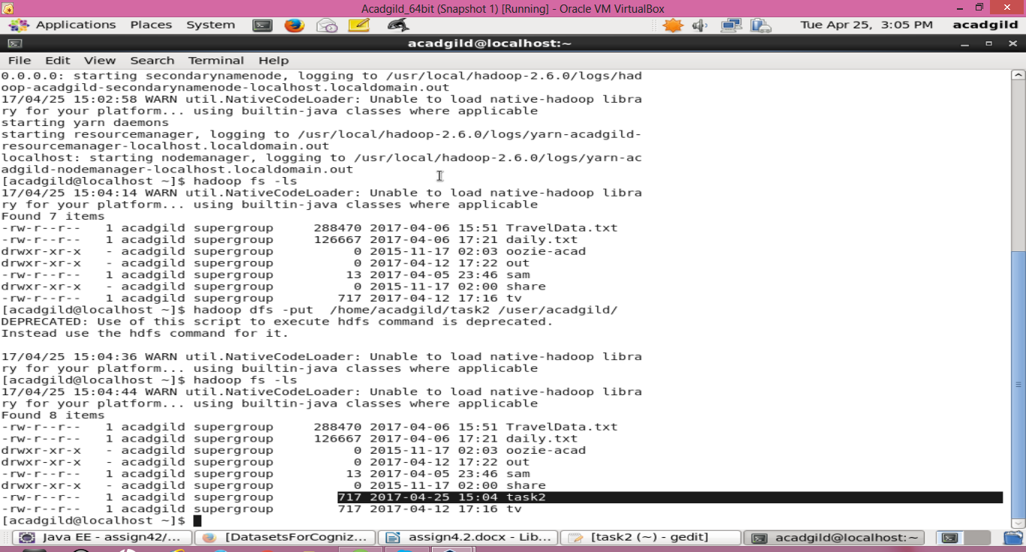

MainDriver.java

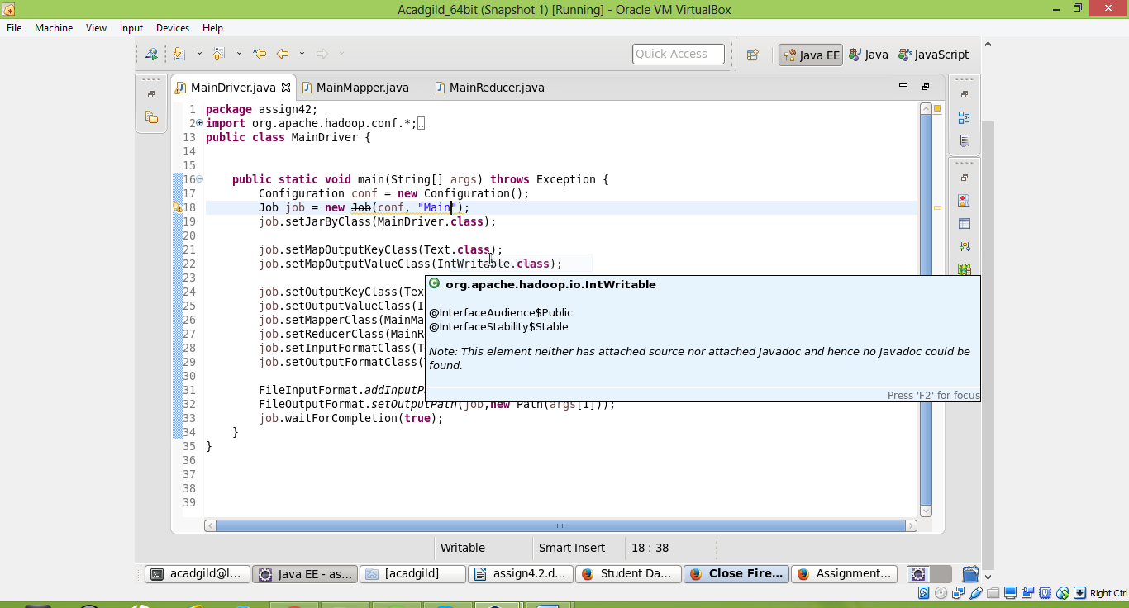

MainMapper.java

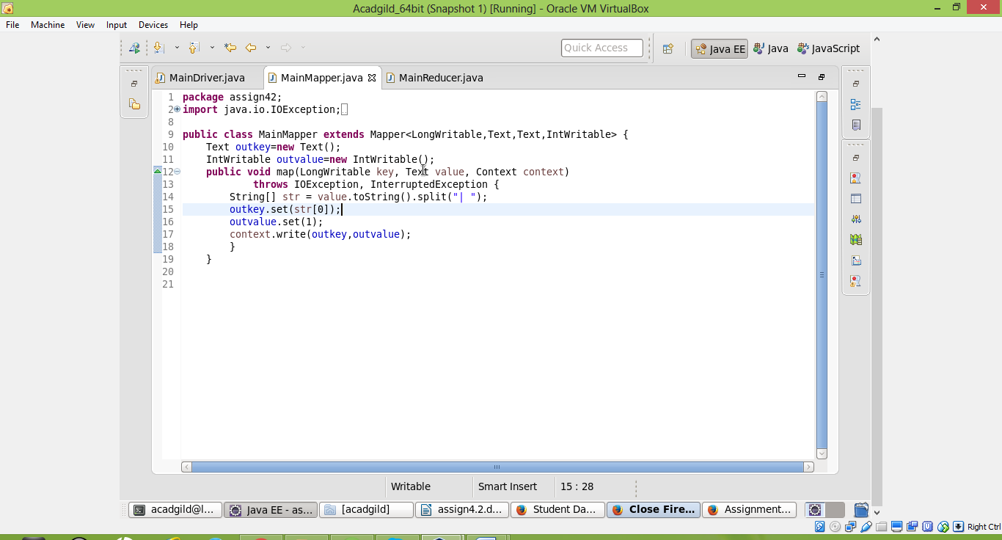

MainReducer.java

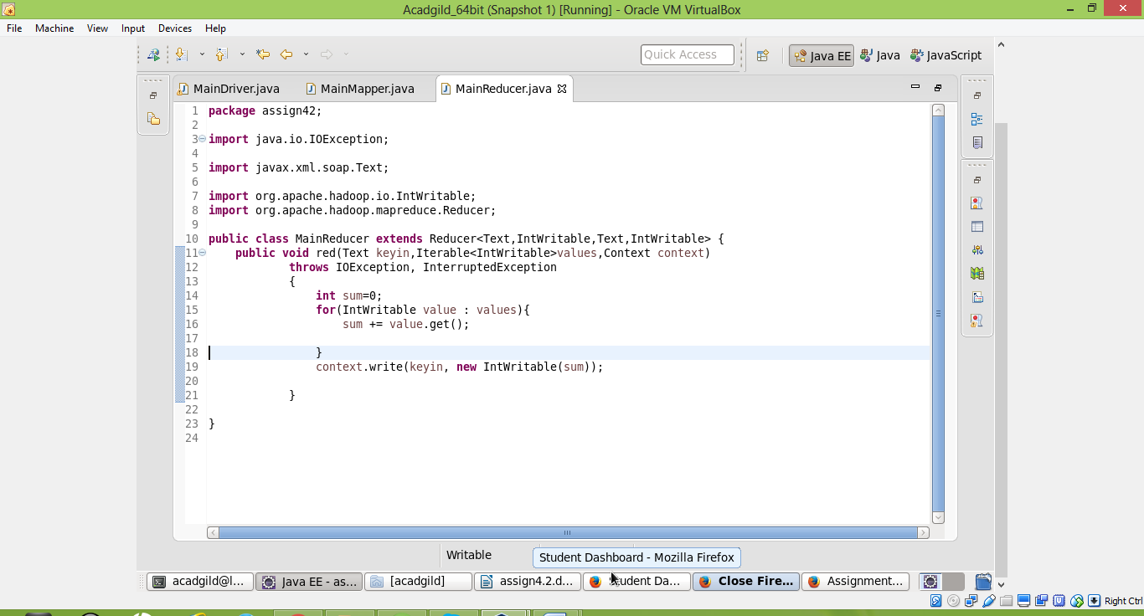

solution

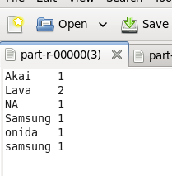

Sales of different TV Task 3: Write a MapReduce program to calculate the total units sold in each state for Onida company.

MainDriver.java

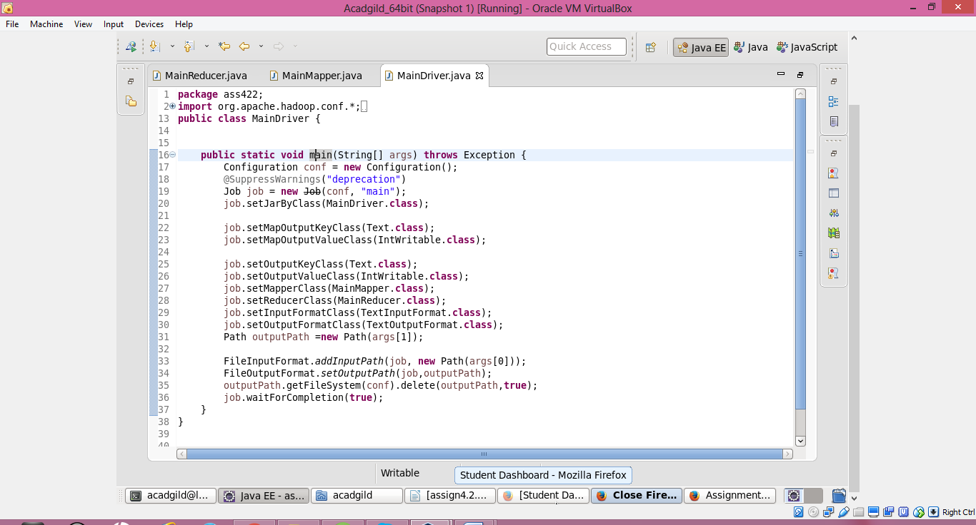

MainMapper.java

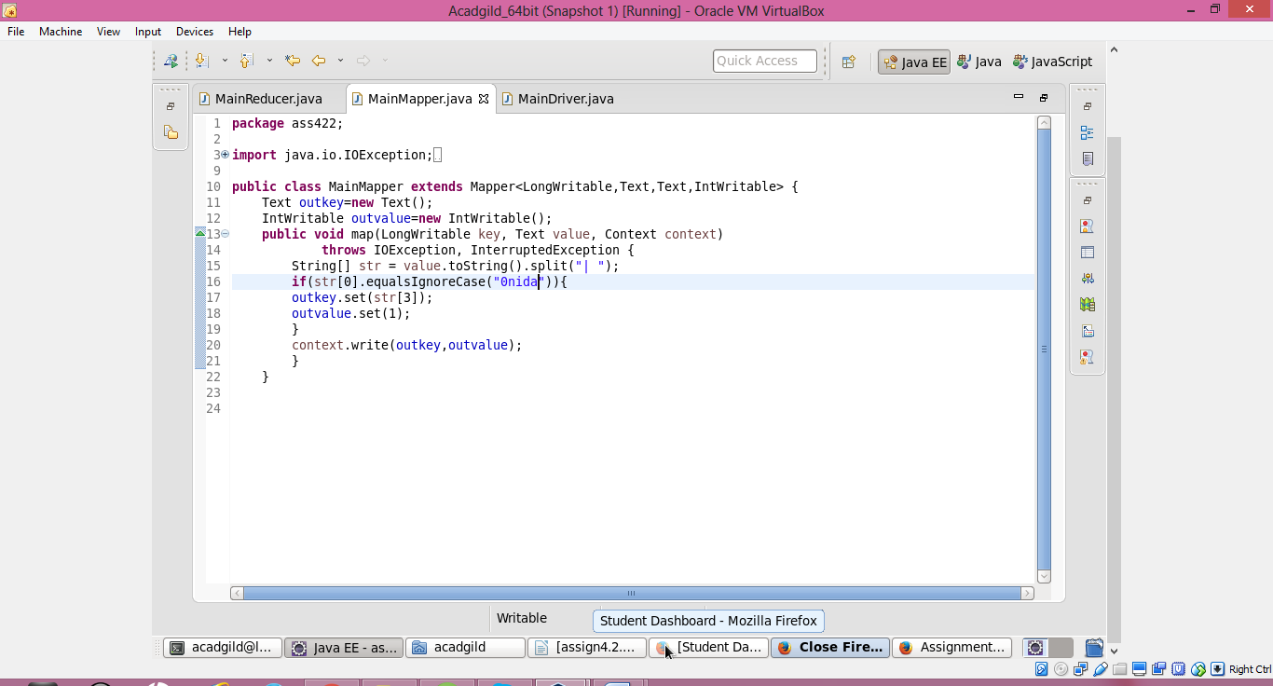

MainReducer.java

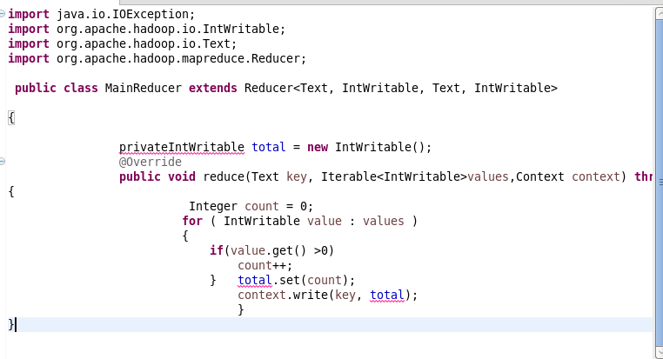

RESULT

